digital libraries for presentation and preservation of east-cristian heritage
Desislava Paneva
Institute of Mathematics and Informatics – Bulgarian Academy of Sciences, Sofia, Bulgaria
dessi@cc.bas.bg
Lilia Pavlova-Draganova
Laboratory of Telematics – Bulgarian Academy of Sciences, Sofia, Bulgaria
lilia@cc.bas.bg
Lubomil Draganov
Institute of Mathematics and Informatics – Bulgarian Academy of Sciences, Sofia, Bulgaria
lubo@cc.bas.bg
Abstract

This article aims to present the digital libraries with multimedia content as a technology for innovative presentation of cultural and historical values. It includes some basic concepts of digital libraries with multimedia content and a description of three types of architecture. Finally, it describes the ideas, conceptual decisions and strategies for implementation of digital libraries with multimedia content in two Bulgarian projects for presentation of East-Christian Icon art and cultural heritage in the global information space.
Keywords
Digital libraries with multimedia content, digital library architectures, cultural heritage, East-Christian Icon art.
- INTRODUCTION
Preserving the cultural, historical and scientific heritage of various world nations, and their thorough presentation is a long-term commitment of scholars and researchers working in many areas. From centuries every generation is aimed at keeping record about its labour, so that it could be revised and studied by the next generations. New information and multimedia technologies have been developed during the past couple of years, which introduced new methods of preservation, maintenance and distribution of the huge amounts of collected material. There are various conceptual and technically feasible solutions available, such as digitalization of cultural and historical artefacts and creation of multimedia information archives, web presentations of valuable artefacts in virtual museums, galleries and digital libraries, 3D virtual realities, which present places of culture and history, digital modelling and simulation, aiding the conservation, restoration, storing and showing artefacts, etc.
This article aims to present digital libraries with multimedia content as a modern technological solution for innovative presentation of the variety of Bulgarian Icon art and cultural heritage (churches, monasteries, murals, etc.) from different artists, historical periods, and schools. The contemporary digital libraries have been made possible via the integration and use of a number of information and communication technologies, the availability of digital content on a global scale and the strong demand for users who are now online. It is expected that they should enable any citizen to access human knowledge any time and anywhere, in a friendly, multi-modal, efficient, and effective way. A core requirement for such digital libraries is that they have a common infrastructure which is highly scalable, customizable and adaptive. This article describes three types of architecture with different complexity. Considering the specific needs and requirements of different cultural and historical heritage projects some of these architectures could be chosen. The last part of this article describes the ideas, conceptual decisions and strategies for implementation of digital libraries with multimedia content in two Bulgarian projects for presentation of East-Christian values in the global information space.
- basic concepts of digital libraries with multimedia content
Digital libraries with multimedia content are a contemporary conceptual solution for access to information archives. According to an informal definition of digital libraries, they are managed collections of information, with associated services, where the information is stored in digital formats and accessible over a network. Digital libraries contain diverse hypertext-organized collections of information (digital objects such as text, images, and media objects) for use by many different users. The collected information is organized thematically and uses hyperlinks that allow the connection between any piece of data and additional data on the same topic. As an addition to the digital objects collection, there are many levels of metadata, indexes, hierarchical links, etc. [3]
The main characteristics of digital libraries are the following:
- Ability to share information;
- New forms and formats for information presentation;
- Easy information update;
- Accessibility from anywhere, at any time;
- Services available for searching, selecting, grouping and presenting digital information, extracted from a number of locations. Using these services depends on the user preferences, needs and wishes of the users, i.e. there is personalization available;
- Contemporary methods and tools for digital information protection and preservation;
- Ability to use different types of computer equipment and software;
- No limitations related to the size of content to be presented.
In the past digital libraries were isolated and monolithic systems limited to access to content of a single provider. The development of the technologies during the last years provides new functionalities and advanced services to contemporary digital libraries such as specialized services for
- Multi-layer and personalized search, context-based search, relevance feedback, etc.
- Resource and collection management;
- Metadata management;
- Indexing;
- Semantic annotation of digital resources and collection etc.
The new digital libraries will provide and manage complex services, processes and workflows on the basis of existing services. It is expected that these services be heterogeneous, autonomous and distributed. The flexibility, the automatic adaptation, the access anywhere and anytime, the decentralization, the wide variety of digital objects and collections, the information security, etc. will be of the some requirements. [1] [2]
Digital library architectures
A Hypermedia digital library can be considered as a database, storing data of different type (text, raster, vector, static and moving (video) images, animation, audio or other media), which is structured in a way to allow easy manipulation and use. Data is stored in the database in the form of objects, usually annotated to facilitate running search queries. To make these procedures automatic, the hypermedia library includes techniques for descriptive presentation of the data semantics as well as services for its management.
Web technologies help organizing hypermedia digital libraries by providing a means to structure and present them in a hypermedia manner. Hypermedia represents hypertext media; therefore it adheres to the hypertext information organization rules. Users are allowed to quickly move across subject-related topics in a non-linear way. These topics may include sets of objects, such as text, images, audio and other media, which relate to one another via hyperlinks.
The Hypermedia digital library in the Web space is a simplified conceptual solution for presenting complex multimedia content.

Grid-based infrastructures - The digital library is currently undergoing a transition from a statically integrated system to a dynamic federation of services. This transition is inspired by new trends in technology which include developments in technologies like Web services and grid infrastructures as well as by the success of new paradigms like Peer-to-Peer Networking and Service-oriented Architectures. The transition is driven by digital library "market" needs. This includes a requirement for a better and adaptive tailoring of the content and service offer of a digital library to the needs of the relevant community as well as to the current service and content offer, and a more systematic exploitation of existing resources like information collections, metadata collections, services, and computational resources.
Such new decentralized and service-oriented architectures for digital libraries make the library functionality available in a more cost-effective and tailored way and thus open up new application areas for digital libraries. Future digital libraries should enable any citizen to access human knowledge any time and anywhere, in a friendly, multi-modal, efficient, and effective way. A core requirement for such digital libraries is a common infrastructure which is highly scalable, customizable and adaptive.
A grid is a network or collection of distributed computer resources, which are accessible through local or global networks and are presented to the end user via an enormous virtual computer system, i.e. it is a virtual, dynamically changing organization of structured resources, which are shared among individuals, institutions and systems. Some of the main advantages of the grid technology are: optimized and personalized access and enhanced management of digital resources; virtual resource organization; ability to be used worldwide, etc. The grid technology introduces essential improvements in the current distributed information systems, which are the proper basis for building contemporary digital libraries.
In essence, the creation of virtual digital libraries on the basis of grid-based infrastructures, support for the integration of metadata, personalization services, semantic annotation and the on-demand availability of information collections and extraction services will make digital libraries more useful and attractive to a wider clientele. Such a test-bed digital library infrastructure has been created for the DILIGENT project (Integrated project funded in part by the European Commission FP6 IST Programme), based on the grid technology [7]. Figure 1 depicts DILIGENT infrastructure.
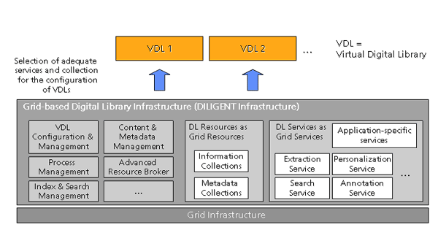
Figure 1: Grid-based digital library infrastructure

Hyperdatabase infrastructure - Future digital libraries should enable any citizen to access human knowledge any time and anywhere, in a friendly, multi-modal, efficient, and effective way. A core requirement for such digital libraries is a common infrastructure which is highly scalable, customizable and adaptive. Ideally, the infrastructure combines concepts and techniques from peer-to-peer data management, grid computing middleware, and service-oriented architectures. That infrastructure is offered in the project DELOS “A Network of Excellence on Digital Libraries” funded by the EU's Sixth Framework Programme. [5]
Peer-to-peer networks allow for loosely coupled integration of digital library services and the sharing of information such as recommendations and annotations. Grid computing middleware supports the dynamic allocation and deployment of complex and computationally intensive digital library services such as the extraction of features from multimedia documents to support content-based similarity search. A service-oriented architecture provides common mechanisms to describe the semantics and usage of digital library services. Furthermore, it supports mechanisms to combine services into workflow processes for sophisticated search and maintenance of dependencies. As depicted in Figure 2, the digital library architecture envisaged consists of a grid of peers which provide various kinds of digital library services such as storage, extraction or retrieval services. These digital library services can be combined with processes. High scalability is achieved by executing the processes in a completely distributed, peer-to-peer fashion. For that, metadata about processes, services, and load of the peers is distributed and replicated over the grid. This is performed by a small hyperdatabase layer atop each peer. This layer also takes care of peer-to-peer navigation and execution of processes. Figure 2 depicts the execution of the process "Insert Image".

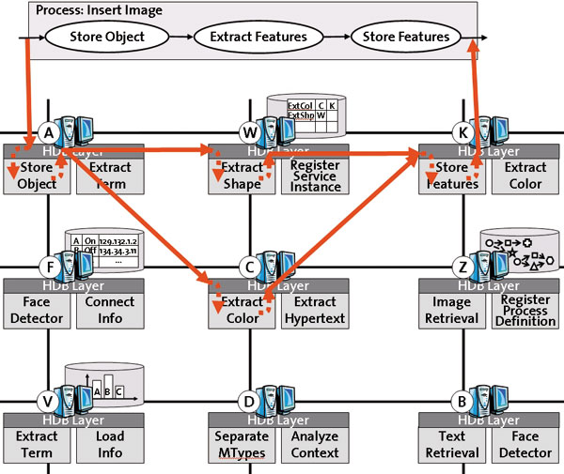

Figure 2: The execution of the process "Insert Image" in digital library architecture based on a hyperdatabase infrastructure

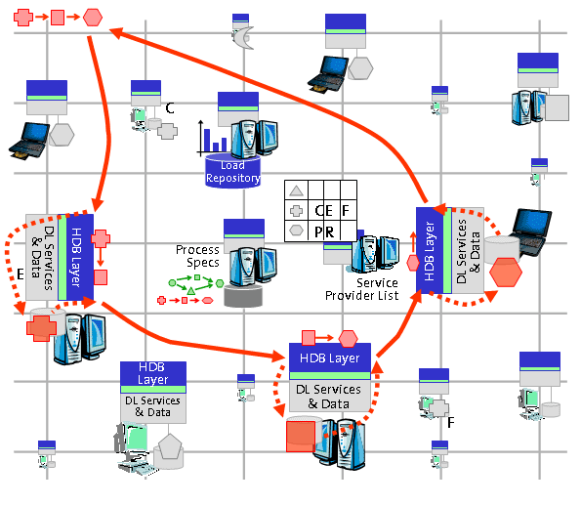
Figure 3: Digital library architecture based on a hyperdatabase infrastructure
- digitization of european’s cultural and historical heritage
Europe’s cultural, historical and scientific knowledge resources are a unique public asset forming the collective and evolving memory of our diverse societies. Resource discovery, accessibility, usability, interoperability, authenticity, quality and trust by all users of the Information Society are essential requirements for the delivery of digital cultural information and services. [4]
European libraries, archives and museums contain a wealth of information, representing the richness of Europe’s history, its cultural diversity and its scientific achievements. The degree of access to this information determines how far people can experience their cultural heritage and benefit from it in their work or studies. By digitising their collections and making them available online, libraries, archives and museums can reach out to the citizens and make it easier for them to access material from the past. The online presence of this material from different cultures and in different languages will make it easier for citizens to appreciate their own culture heritage as well as the heritage of other European countries, and use it for study, work or leisure. [6]
The "i2010: Digital Libraries" initiative aims at making European information resources easier and more interesting to use in an on-line environment. The Commission adopted on 30/09/2005 the "i2010: Digital Libraries" communication outlining the vision of this initiative and addressing in particular the issues of digitisation, on-line accessibility and digital preservation of our cultural heritage. [9]
- Digital Libraries of East-Christian Icon Art
East-Christian icon art is recognised as one of the most significant areas of the art of painting. Regrettably, it is still being neglected in the digital documentation and the registry of the art of painting. The accessibility to that large part of mankind's cultural and historical ancestry would be enhanced greatly if icons of all possible kinds and origins were digitised, classified, and „exhibited“ in the Internet. That would allow the preservation and even the future digital restoration of a large number of rare specimens of the East-Christian art of painting. The need for a wide accessibility and popularisation is even bigger for the Bulgarian icons. Therefore, it is necessary that their idiosyncratic art and exceptional values be made available in the global information medium, so that they become accessible to both professional researchers and the wide audience.
The goal of the project “Virtual encyclopaedia of the art of the Bulgarian icon“ is to develop the information content, structure, and the realisation of a digital multimedia library as a demonstrator of virtual encyclopaedia of the Bulgarian iconography“. That library will include several hundred specimens of Bulgarian icons from different artists, historical periods, and schools. The chosen architecture represents a web-based hypermedia digital library, which means that presentation of a complex multimedia content in the Internet is simplified. The resources are digital objects of different formats – text, graphics, and other media. They will be structured in a hypermedia way, i.e., some digital objects point to other ones. In this way the user can navigate quickly, in a non-linear fashion, within areas of related topics, using the hyperlinks. The digital objects will be grouped according to their topics into thematic collections. For each object and collection, special meta-descriptions will be created. They will include data about the artist, the period, the school, the location, the material used, the category. Also, they will contain links to other digital objects and collections, keywords, and so on. That information will be used for the semantic annotation and indexing of the digital objects, which will facilitate their locating during search requests, and their web-based representation. A multitude of specialized services for metadata management, content management, indexing, metadata annotation of digital objects and collections, creation of requested document, different media types search, context-based search, multi-object, multi-feature search, etc, will be presented. Figure 4 depicts the architecture of hypermedia digital library in Web. The organisation of the media databases, the representation and description of the digital objects, and the classification of the artefacts, will be developed according to the recommendations of the international group of museum experts of East-Christian Art (UNESCO/I.DB.I) and the standards of CIDOC/MICMO. The project relies on the idea that the unity of the text information and the high quality of the digital images will represented the virtues of the Bulgarian icon in their entirety and will contribute to the its preservation, wider exhibition, and future potential restoration. The demonstrator that will be developed will be a tool for exploration of the techniques, styles, colours, and forms, as well as for the tracking and comparing of specimens and periods of the iconography and historical development of that art. The project will lay the foundations of the registration, documentation, and the exploration of a practically unlimited number of Bulgarian icons. The tools of the virtual encyclopaedia will give the users the opportunity to compare the icons in their historic context, so that some yet undiscovered treasured of the East-Christian iconography be manifested.

WWW browser
User interface
Request
for service
User query
Document
request
server
Repository
Repository
Repository
Document
request
Available services
Request for specialized service
Specialized service
Digital library with multimedia content
Metadata-annotated digital objects associated with thematic collections: annotated text, annotated images, annotated sound files, annotated video, etc.
Repository
Specialized services for:
metadata management;
content management;
indexing;
metadata annotation of digital object and collection;
creation of requested document;
...
different media types search;
context-based search;
multi-object, multi-feature search;
…

Specialized service
Specialized service
Services
creating a
requested
document

Figure 4: Hypermedia digital library

The project „Virtual encyclopaedia of the art of the Bulgarian icon“ is a superstructure and further development of the European (FP5) project I.DB.I “International Database on East Christian Icon Art: Access to the World of Icon Art” [8]. A lot of work is done on that project for the creation of a high quality interface to a developed multimedia database of several hundred pieces of art of different authors, periods, and schools of the East-Christian iconography. That group includes painted icons and icons built with mosaics that are located in European museums, churches, monasteries, and private collections. The user interface offers novel tools and techniques for navigation, browsing, searching, and retrieval of digital representations of icons of the East-Christian iconography.
A project that has a similar subject is “Bulgaria SACRA”. Its goal is to present the top achievements of the religious cultural-historical heritage of Bulgaria, too. However, its emphasis is on the architecture, the monuments, murals, etc. The technology of choice is yet again digital library with multimedia content, though in this case it aims at a complete description and multimedia representation of complex objects and their constituents, rather than stand-alone artefacts. For instance, an object-church with a general 2D and/or 3D view, a general and exterior architectural blueprint, a general interior blueprint, murals, iconostasis, icons, and so on. In this way we create a complete description of the chosen specimens. A special ontology describing completely the physical object of consideration and its constituents, their attributes, connections and relations between them, will be developed. We plan to accomplish a complex multi-object and multi-feature searching based on the semantic annotation and indexing of the complex objects. The final product of this project is planned to be an information artery for virtual representation of Bulgaria SACRA in the European and the global information space using the technologies of the digital multimedia libraries.

REFERENCES

- K. Kiernan, A. Kekhtyar (2003). EPT: Edition Production Technology for Multimedia Contents in Digital Libraries, Presented on Workshop on Multimedia Contents in Digital Libraries, USA
- IEEE Multimedia (2000), Virtual Heritage, April-June, Vol.7, No.2
- D. Krastev (2005). Central Library of Bulgarian Academy of Sciences – present and future, The libraries of Bulgarian Academy of Sciences, Reference book, Bulgaria
- eEurope and Digitisation - http://www.cordis.lu/ist/digicult/eeurope.htm
- Project DELOS: A Network of Excellence on Digital Libraries - http://www.delos.info/
- Project MINERVAEUROPE: Ministerial Network for Valorising Activities in digitalisation - http://www.minervaeurope.org
- Project DILIGENT: Digital Library Infrastructure on Grid Enable Technology - http://www.diligentproject.org/
- Project I.DB.I: International Database on East Christian Icon Art: Access to the World of Icon Art (2000). RTD Proposal: Description of scientific/technological objectives and workplan (Part B)
- "i2010: Digital Libraries“, COM (2005) 465 final, Brussels, 30/09/2005

